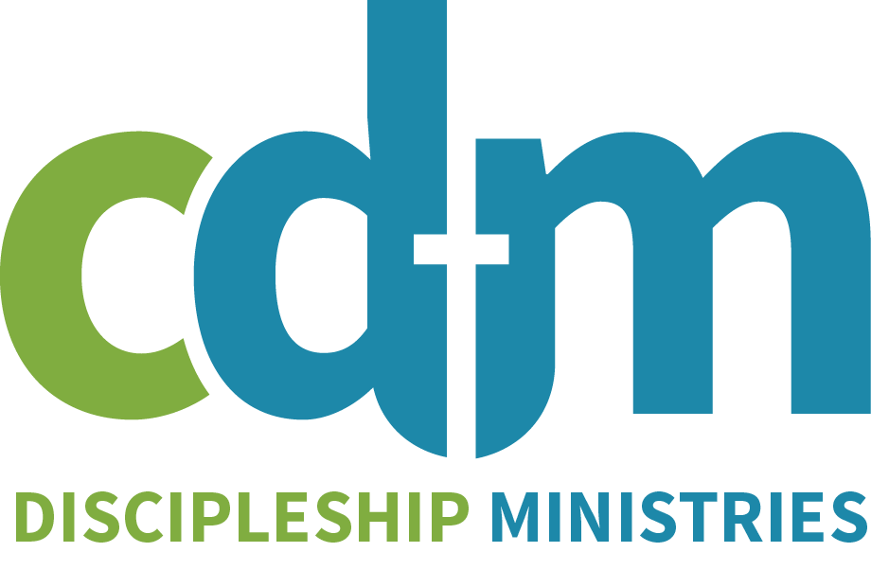
Manuscript Submission Form

for

CDM’s vision is to strengthen the Church by providing biblical resources that promote a biblical worldview that is anchored in the inerrant Word of God, centered on the Gospel, and in agreement with the doctrines taught in the Westminster Confession of Faith. Due to the unique nature of our ministry to promote discipleship in the local church, we are very selective in the resources we publish; yet, we desire to review manuscripts for studies design for children, youth, and adults.

If you are interested in submitting a book idea or a manuscript in keeping with the mission stated above, CDM welcomes your proposal in the following areas:

Studies for children, youth, women, men, or seniors

Discipleship Resources for Small Groups

General Bible Studies (6-10 weeks max.)

Resources for Churches, Pastors, or Leaders

PLEASE READ BEFORE SUBMITTING A PROPOSAL

- Even if your manuscript is complete, we require you to submit a proposal instead of the manuscript.
- All proposals must be received electronically. We will not respond to, or return, proposals submitted by mail.
- Please complete all parts of this submission form, or explain why you cannot.
- We rigorously review the manuscript proposals we receive. You can expect a response to our evaluation of your proposal within one to two months.

AUTHOR INFORMATION

- Are you a member of a PCA church in good standing? (CDM is a committee for the PCA. As such, submissions are encouraged to be accompanied by a letter from an ordained PCA pastor or elder.)

- Present employment:

- What qualifies you to write this book? What is your education, experience, and professional expertise?

- Why did you write this book? Do you have a unique perspective or experience to share?

- Previous books or articles published:

MANUSCRIPT CONTENT AND CONDITION

Title _________________________________________________

Subtitle _________________________________________________

Author or Editor _________________________________________________

Address _________________________________________________

Cell Phone _________________________________________________

E-mail _______________________________________________

Office Phone _________________________________________________

- Which category best describes your submission?

Studies for children, youth, women, men, or seniors

Discipleship Resources for Small Groups

General Bible Studies (6-10 weeks max.)

Resources for Churches, Pastors, or Leaders

- Is the manuscript finished? If not, when will it be? (mm/yyyy)
- Give us a summary of your book in approximately thirty (30) words.

- Give us a summary of your book in approximately one hundred fifty (150) words

- Provide chapter summaries of how you develop themes and material in your book proposal.

- Include a file containing a table of contents and 2 or 3 sample chapters of your proposed book.

- What main points are you attempting to communicate? How would your book strengthen the church?

AUDIENCE

- It is important to know who the book is intended to reach. Describe the target audience of your book:
  - Age:
  - Gender:
  - Education:
  - Experience:
  - Other specifics:

- How do you hope your book will impact readers? Provide examples of how readers will benefit from reading your book. (Don’t focus on what the book does but what difference it will make to the reader.) Be as specific as possible.
1.
2.
3.

- Provide example of what is new, distinctive, or groundbreaking about your book. (Why would someone
1.
2.
3.

- Have you given this to any recognized authorities on this topic who has read this proposal and who would be a reference? If so, please include their name and contact information.

- CDM strongly encourages authors to test their material on a small group or in their home church before submitting it for publication. Doing so will help you fine tune your manuscript. Has your material been small group tested? What was the response? Who in your test group could we speak with to share about how your material impacted them? Please include both name and contact information.

PARTNERING WITH CDM TO MARKET YOUR BOOK

At CDM we use social media, email blasts, and our website to help market the books we publish, but we also expect our authors to aggressively promote their books. This involves having a presence in social media, assembling a team to pray both for the production of the book but also its reception, tapping into your own networks to promote the book, and being willing to share about your book through speaking engagements and written articles.

- We encourage you to do a Google search about your topic, title, and look at books that would compete with yours. We also encourage you to do a hashtag search of your topic and/or title. Tell us the books you see as competing with yours, and briefly explain why yours is better?

Are there any CDM titles already in publication that are similar to your submission?

- List any ministries or organizations with which you are connected that would be interested in your book?

- Do you have any scheduled speaking events?

- What is social media presence? Are on Facebook, Twitter, Instagram, or other social media?

- Do you have a website or blog? If so, please list it.
SUBMISSION PROPOSALS CAN BE EMAILED TO:

cdm.publications@pcanet.org

***ALSO SUBMIT AN OUTLINE AND 2-3 CHAPTERS OF YOUR BOOK IN
A SEPARATE MICROSOFT WORD FILE
Whew! You made it! At CDM, it is our mission to strengthen the church by producing dependable resources that glorify God and encourage believers. We have a small publishing team, and we have to limit the projects we can do each year. Our process for selecting those projects involves a team of people and many hours of prayer. Will you join us in praying that we would be good stewards of the resources we have been given by choosing the right projects to build up the Body of Christ? Thank you!

